**Tower Defense**

**Game Concept**

2d tower defense game with a fantasy theme.

You play as a dragon defending your hoard of gold from humans that have come to take your gold

As the dragon you have abilities to defend yourself from the approaching humans

You can spend currency to build and upgrade defenses.

Survive waves of enemies to progress in levels. Each new level steadily increases in difficulty.

**General limitations**

* + Two phases to the game, build phase and combat phase
  + Two Resources for the player to manage
    - Meat to spend on new defenses and upgrading existing defenses
    - Gold representing the health of the dragon, game ends when 0 gold remains
  + Enemies travel along a set path.
  + Enemies have speed and health
  + Limited build area for defenses
  + Defenses have attack, attack speed and range
  + Dragon has a set amount of gold that can be lost before defeat
  + Dragon has abilities that can be used to actively aide in the defense during combat phase

**Player Experience Goals**

* The player will utilize long term resource placement strategies During the build phase aiming to survive as many rounds as possible.
* each ability should feel powerful and useful. Giving the player the impression that they are powerful
* The player will play competitively against their own highest round, in an attempt to beat personal records and last longer before losing the game.
* The player should feel a level of accomplishment from surviving into higher levels of the game.
* Player should feel a sense of disappointment/loss when they lose the game.

**Gameplay Summary**

You play as a dragon protecting your gold from humans that will enter your lair, follow a set path until they reach you take a portion of your gold and attempt to exit your lair by following the same path previously taken.

You can purchase defenses using meat. Meat is gained through killing enemy creeps.

You can also upgrade existing defenses by spending meat. Upgrading allows the user to upgrade a specific defense for a tower (Attack Damage, Attack Speed, and Attack Range)

The score is the round wave that you manage to successfully survive till.

To get through a wave all enemy creep must be killed or have escaped.

If 20 gold pieces are stolen the game is over.

Game summary

* Tower Defense game
* The primary resources are:

- Spending currency(gained from killing enemy creep)

- Time cool downs(on abilities during combat phase)

* There are two phases to the game. Build phase and combat phase

* You play as a dragon defending his/her hoard of gold from human invaders.
* During the build phase you can:

- Build defenses (build button)

- Upgrade defenses(upgrade button)

* During the combat phase you can

- Use abilities to aide in your defense(located at the bottom

left and right of the screen)

* There is a set number of enemy creeps per wave
* Once all creeps have been killed or have escaped the round will end.
* If 20 pieces of gold are stolen the game is lost.

**Game Modes**

- Build phase

* Allows player to build and upgrade defenses using available currency.

- Combat phase

* Player can no longer build or upgrade defenses.
* Player can use the four abilities located along the bottom of the screen
* abilities have a cool down period after use, limiting the number of times that a player can use them in combat.

**Tower Types**

* Basic Tower: Goblin Crew, Basic but versatile.
* Short range Tower: Minotaur, Short range but tough.
* Long range Tower: Drake, Slow and powerful.

Stats are Power, Speed and Range. Towers cost Meat to make and upgrade

Each tower can be upgraded a limited number of times. Sometimes maxing out a particular attribute grants extra abilities.

**Dragon Abilities**

* Fireball: Allow dragon to temporarily use a basic attack on enemies within range.
* Intimidating Roar: Slows and lowers defense of creeps for a short duration.
* Stomp: Staggers all enemies(halts progression temporarily). Duration is based on how close to the dragon. (potential to cause damage to enemies in close proximity to dragon)
* Magma Blast: Draconic Tactical Nuke. Ability that starts on cool down at the start of the combat phase. Large cool down period that allows the user to select the destination of a high damage area of effect attack.

**Enemies**

Stats are HP, Movement Speed, Defense

* Townsfolk: Basic creep. Average in all stats
* Thief: Fast creep. Low HP, High Speed and Low Defense. Can steal more treasure.
* Shield man: Tank creep. High HP and Defense, Low Speed. (potential to draw fire from nearby turrets, over other creep)
* Berserker: Rage creep. High HP, average Defense and Speed. Moves faster when Intimidated(by dragons roar) but defense drops more.

**Menu Structure**

* Launching the application will take the player to the Main menu, from there the player can proceed to:

- Game screen (continue or new game buttons)

(new game requests confirmation from player if new game will overwrite existing game data)

- Setting screen (settings button)

- Out of the application(Exit Game button)

* In the Game screen the player has the option to:

-pause the game(pause button)

- build screen(build button)

- upgrade screen(tapping on existing defense)

* The Pause screen gives the player the option to

- Resume the game(Continue Button)

- Setting Screen(settings button)

- Exit Level(Exit Level button)

* From the settings screen the player can:

- Return to game(back button)

- Return to Main menu(back button)

Function of back button changes depending on how the player entered the settings screen)

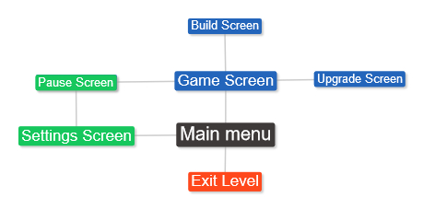

Application navigation map.

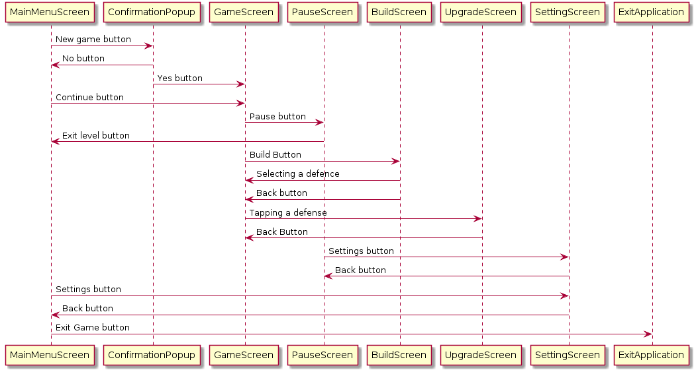

**Game Mechanics**

* Start button

- Start next wave

* Pause button

- Pauses the game and brings up the pause menu

* Build button

-brings up the build screen

- when a defense has been chosen from the defense screen,

close the defense screen, place the defense on the next location tapped by the player

* Waves

- A set number of enemies based on the wave level

- End of wave starts the next build phase

* Path

- All enemies follow the same path

- list of points with x,y coordinates

- defenses cannot be built on the path.

* Enemies

- Health

- Speed

- Defense

- Type

- (Stats are based on the wave level)

- Death of enemy gives a set amount of currency

* Defenses

- Attack Damage

- Attack Speed

- Attack Range

- Type

- stats can be upgraded by spending currency

* Dragon

- Fire ball(short cool down, allows the dragon to auto attack enemies in range for a short duration)

- Roar(medium cool down, Slows enemies and lowers defense temporarily)

- Stomp(medium cool down, stops enemies progression momentarily)

- Magma blast(long cool down, target area for dragon to shoot ball of magma which deal large damage to an area)

* Resources

- Meat(primary currency used to purchase and upgrade towers, earned through killing enemy creep)

- Time(Managing ability cool downs to gain the best effect out of limited use abilities)

- Remaining gold(enemies attempt to steal gold, if 20 gold is stolen the game is over)

* Score

- Waves successfully survived

* Saves

- bool isSave - int highestWaveCount(persists through games)

- int waveCount

- list(Defenses(type,atkLevel,spdLevel,RngeLevel,Point(x,y))

- int remaingGold

- int totalMeat